My Flipped Classroom Workbook
Version 1.0 by Daniel Lambach
Released under a CC-BY-NC-SA 4.0 license

This little Workbook is designed to help you flip your classroom. My experience is mainly with the German academic system and my own teaching is in the social sciences, so you might have to think about adapting certain aspects to make them fit your own personal circumstances. It also assumes a basic structure of one asynchronous (preparatory, out-of-class) and one synchronous (attendance, in-class) phase per learning unit, although you can simply fit the exercises to your approach as necessary. I’m not the Flipped Classroom Police – be creative!
If you have any suggestions for improvement, email me at kontakt@daniel-lambach.de.

Why flip?
The first part of any project is to find your Why. Which experiences, which considerations make you want to flip your class? What do you hope to see in a flipped class? How will this change your teaching?
Think about these questions. Do whatever helps you reflect – go for a walk, talk to a mentor or a friend, do some journaling or draw a mind map – and write down your Why in the box below. This will be a good reminder down the line why you embarked on this project and helps keep you aligned with the overall goals behind the flip.

Working with outside expectations
Your course takes place within a particular (educational, disciplinary, institutional etc.) setting which imposes certain limitations on you and your teaching. For example, course descriptions, exam regulations etc. often predetermine what kind(s) of exams you may use in your course. You’ll have to work with that – or, at least, if you want to break the rules, know what you’re in for and who you might have to negotiate with. If you are teaching in a professional field (e.g. accounting, medicine, law, education), there might also be guidelines by professional associations or legal standards that may also impact your course. Be aware of those.
Consult the relevant handbooks, course descriptions, and exam regulations for this particular course and collect the following:
- What they say about the aims and learning outcomes.

- What they say about the content.

- If forms of assessment are already determined and what options you have in terms of grading.

- If this course is a prerequisite for other courses later in the program and which other courses (if any) are prerequisites for this course.

Things to consider
Flipping a classroom is not limited to particular teaching scenarios – you can flip a large undergraduate course just as much as a small graduate seminar. But the circumstances of the course affect how you are going to flip it and inform your choice of learning activities. To make informed choices later, collect as much of the following information as possible:
How many credits do students earn for completing your class? How many hours of work per week can you reasonably expect from students?

How many students will take the class?

What year are these students? Are there any prerequisite classes that participants will already have completed? Are there other forms of prior knowledge that you can or should build on?

How diverse is your class, e.g. do you have students from different degree programs, from other countries etc.?

Is there a Learning Management System that all students can access? How well do you know it?

What is the physical environment of the class, e.g. the size of the room and whether tables and chairs can be rearranged? If an online class, which software will be used?

What is the schedule? Is it a weekly class meeting, is it a ‘block seminar’ kind of class?

Is attendance compulsory? Do you have options for incentivizing participation and preparation?

Learning outcomes
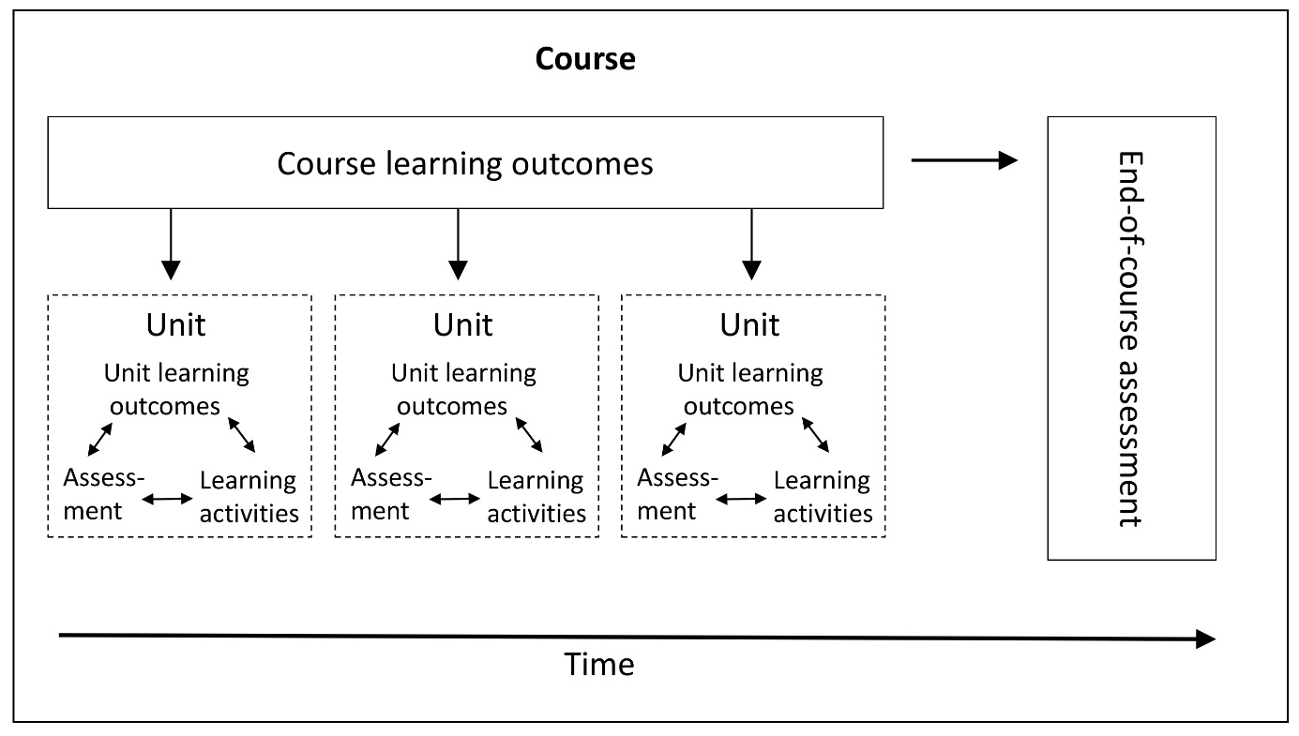
Source: Lambach, Daniel/Kärger, Caroline (2021): Inverting the Classroom in Large-Enrollment Classes: A Beginner’s Guide. In: Journal of Political Science Education 17(4): 641-652.
You need to define the course learning outcomes. There are dozens of different ways of conceptualizing learning and formulating learning outcomes – just pick one that you are comfortable with. If you are unfamiliar with that, try to write clear, declarative sentences what your students will be able to do upon completion of the course.
- Use observable activities in mind – don’t say “students will understand…” but rather “students will summarize/define/explain…”
- Don’t do more than three of four learning outcomes for a typical, semester-long course. That’s plenty.
- Think about including goals beyond analytical capabilities appropriate to your discipline, such as writing, project management, or programming skills.
Write down your learning outcomes in the box below.

Assessment
While you are thinking about the course as a whole, you should also decide upon the form of summative assessment, i.e. through which activities will students demonstrate mastery to earn grades? (Summative assessment is compared against educational benchmarks for formal certification while formative assessment aims to measure student learning throughout the course and provide feedback to students.) Will it be a single exam at the end, multiple smaller exams throughout the course or a mix of the two? Will these be written or oral exams, term papers, student portfolios, quizzes, performances etc.?
Given the limitations imposed on your class by outside expecations, remember to align the form of assessment with the overall learning outcomes. For instance, if one of your learning outcomes is that students should be able to write scientific papers, assessment should include a strong component of students doing exactly that.
First, think of forms of assessment that perfectly match your intended learning outcomes. Be creative and courageous! Then compare your vision with available options and limitations – don’t forget to consider the workload for you and your students.

Here is some additional space for thinking outside the box:
Course content
You also have to decide on the content of the course. Which topics, which knowledge, which literatures do you want students to learn? If you are flipping a class you have taught before using a more teacher-centered approach, this might mean having to reduce the content load – flipped learning achieves deeper learning but takes more time.
Write down all of the aspects you think are crucial to an understanding of the course topic as a whole and fit the course learning outcomes. You can write them as a list or mind map, but any other approach is also fine. If you are having a hard time, consult relevant textbooks for inspiration. In the first step, just get all your ideas out. In the second step, you have to prioritize them (in case there are too many topics) and order them – which ones are more foundational, which ones require knowledge that you first have to establish?

Learning units
The next step is to organize the content into appropriate learning units. You might have already done that in the previous stage, whether consciously or not. If you have weekly class meetings, a weekly learning unit structure might come naturally but you don’t have to do it that way. Write down your list of learning units and assign them dates or timeframes in your course calendar.

The final step in this part is to think about how asynchronous (preparatory) and synchronous (attendance, in-class) phases are sequenced within learning units. A typical approach would be to have units made up of a single asynchronous phase followed by a single class meeting. In the first phase, students gain some basic familiarity with a new topic, which is then deepened and expanded in the second phase. But if you have longer units or more class meetings per unit, other structures become possible. For example, you might have 1) an asynchronous phase, 2) a first synchronous phase where students meet in small groups with tutors, and 3) a second synchronous phase where the whole class meets with the instructor. You can also have asynchronous units at the end of a learning unit, e.g. where students do homework to practice the skills they developed over the course of the unit. You can change the make-up from unit to unit but do this sparingly – if overdone, it will confuse the students.
Your typical unit structure:

Once you have done that, think about how to link the different phases. I like to use Just-in-Time-Teaching but other approaches are also possible. How will you know how well students have done in the asynchronous phase and how will that inform the preparation of your synchronous phases?

Now you have completed all the big-picture planning you need. Congratulations! Take a break with your favorite beverage, go for a walk, play a game!
Preparing individual learning units
Now it’s time to work on the individual learning units that make up your course. You do not need to plan all this out in advance, you just need to stay ahead of your students. But if you have any ideas, this is the place to capture them before they escape!
For each learning unit, the process is the same.
- Assign learning outcomes to individual learning units that are in service to the overall goals of the course and/or that help prepare for upcoming learning units.
- Decide which parts of these outcomes can students achieve on their own. The more basic competencies go in the asynchronous phase, the more difficult ones in the synchronous phase.
- Design an asynchronous phase that pursues these outcomes. Select appropriate materials, exercises, and forms of assessment that are aligned with the learning outcomes. Implement this on your Learning Management System of choice. Remember that students need feedback on all activities. LMS’ have different capabilities for (auto-)grading exercises and assignments.
- Design a synchronous class meeting that builds upon the asynchronous phase. Select materials, exercises and forms of assessment in support of the learning outcomes you developed in step #2. Choose forms of feedback.
This workbook has sheets for up to 15 learning units. With a single page each, they are for capturing ideas. For more detailed planning, you will have to move to a digital document or a longer-form notebook that provides sufficient space to write out your lesson plans.
Each page also has space for extra notes at the bottom. Once a learning unit is over, take ten minutes to reflect on it. What has worked well, what do you wish to change next time, what do you need student feedback for?

Learning Unit #1:
Unit Learning Outcomes (Overall and Asynchronous/Synchronous Phases)

Asynchronous Phase (materials, activities, assessment) Synchronous Phase

Space for Reflection

Learning Unit #2:
Unit Learning Outcomes (Overall and Asynchronous/Synchronous Phases)

Asynchronous Phase (materials, activities, assessment) Synchronous Phase

Space for Reflection

Learning Unit #3:
Unit Learning Outcomes (Overall and Asynchronous/Synchronous Phases)

Asynchronous Phase (materials, activities, assessment) Synchronous Phase

Space for Reflection

Learning Unit #4:
Unit Learning Outcomes (Overall and Asynchronous/Synchronous Phases)

Asynchronous Phase (materials, activities, assessment) Synchronous Phase

Space for Reflection

Learning Unit #5:
Unit Learning Outcomes (Overall and Asynchronous/Synchronous Phases)

Asynchronous Phase (materials, activities, assessment) Synchronous Phase

Space for Reflection

Learning Unit #6:
Unit Learning Outcomes (Overall and Asynchronous/Synchronous Phases)

Asynchronous Phase (materials, activities, assessment) Synchronous Phase

Space for Reflection

Learning Unit #7:
Unit Learning Outcomes (Overall and Asynchronous/Synchronous Phases)

Asynchronous Phase (materials, activities, assessment) Synchronous Phase

Space for Reflection

Learning Unit #8:
Unit Learning Outcomes (Overall and Asynchronous/Synchronous Phases)

Asynchronous Phase (materials, activities, assessment) Synchronous Phase

Space for Reflection

Learning Unit #9:
Unit Learning Outcomes (Overall and Asynchronous/Synchronous Phases)

Asynchronous Phase (materials, activities, assessment) Synchronous Phase

Space for Reflection

Learning Unit #10:
Unit Learning Outcomes (Overall and Asynchronous/Synchronous Phases)

Asynchronous Phase (materials, activities, assessment) Synchronous Phase

Space for Reflection

Learning Unit #11:
Unit Learning Outcomes (Overall and Asynchronous/Synchronous Phases)

Asynchronous Phase (materials, activities, assessment) Synchronous Phase

Space for Reflection

Learning Unit #12:
Unit Learning Outcomes (Overall and Asynchronous/Synchronous Phases)

Asynchronous Phase (materials, activities, assessment) Synchronous Phase

Space for Reflection

Learning Unit #13:
Unit Learning Outcomes (Overall and Asynchronous/Synchronous Phases)

Asynchronous Phase (materials, activities, assessment) Synchronous Phase

Space for Reflection

Learning Unit #14:
Unit Learning Outcomes (Overall and Asynchronous/Synchronous Phases)

Asynchronous Phase (materials, activities, assessment) Synchronous Phase

Space for Reflection

Learning Unit #15:
Unit Learning Outcomes (Overall and Asynchronous/Synchronous Phases)

Asynchronous Phase (materials, activities, assessment) Synchronous Phase

Space for Reflection

